**Experiment 3**

**List out the entities and identify the relationship between them. Also, identify related attributes supposed to be recorded while considering the normalization rule.**

An Entity-Relationship (ER) diagram for a blood donation project would depict the various entities involved in the system and their relationships. Here's a brief outline of what such a diagram might include:

**Entities:**

* **Donor:** Represents individuals willing to donate blood. Attributes could include donor ID, name, contact information, blood type, etc.
* **Blood Bank:** Represents locations where donated blood is stored and managed. Attributes could include bank ID, location, contact information, etc.
* **Blood Donation:** Represents the act of donating blood. Attributes might include donation ID, donor ID, donation date, blood type donated, etc.
* **Blood Transfusion:** Represents the process of transferring blood from a donor to a recipient. Attributes could include transfusion ID, donor ID, recipient ID, transfusion date, etc.

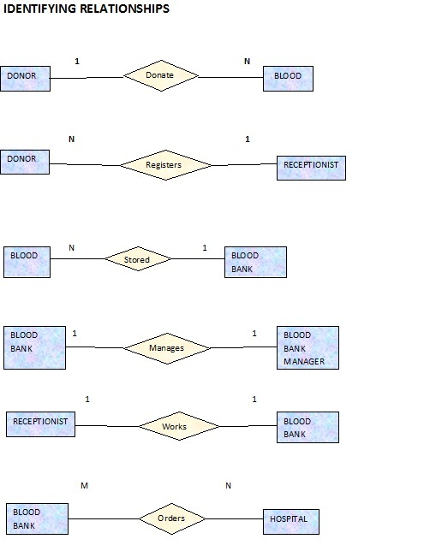

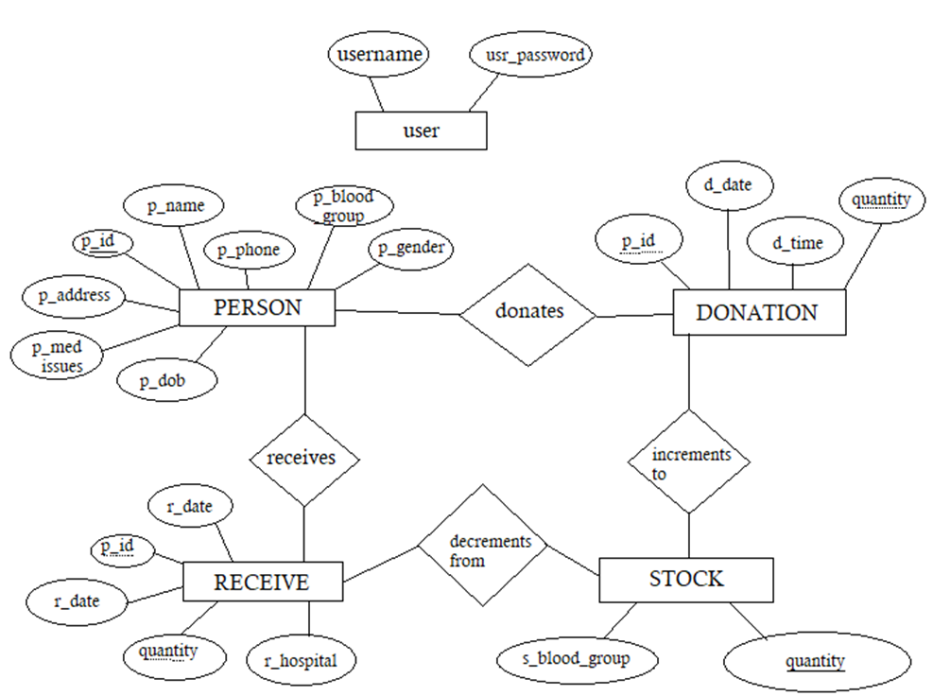

**Fig. ER-Diagram**